Automate Full Stack Application (MERN)
Project 01
Setup Environment
- After creating project folder I create a client and server folder for frontend and backend
- Then I go to server folder using cd server and install npm init -y for initialize node project
- After that I run npm install express mongoose cors dotenv those are the dependencies I want
- Express is like the engine of your backend. It helps your Node.js app handle requests and responses easily.
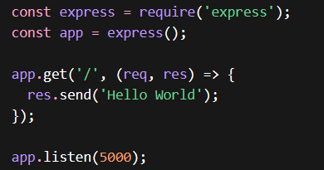

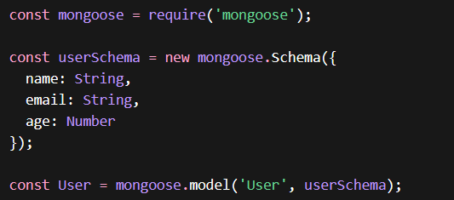
- Mongoose is a tool to talk to MongoDB in a structured way. ODM = Object Data Modeling → it lets you define schemas for your data, so your database knows what “shape” your data should have

- .env file stores secrets or configs separately from code, like API keys, DB URLs, or port numbers.
require('dotenv').config(); - must import env file like this in server file

- CORS = Cross-Origin Resource Sharing
Browsers block frontend code (React) from calling a backend on a different port/domain unless you allow it.

- After that I create models folder inside server folder and inside it I create user.js file for
MongoDB. It tells MongoDB what a user looks like (name, email, age)

- Then I create a routes folder inside sever folder and create routeUser.js file and its
- Take the data from frontend
- Create a new user object
- Save it in MongoDB
- Send a response back

Frontend Setup (Client)
- After go to clint folder I run npx create-react-app . for install react inside folder
- Then I run npm start
- Then I setup app.js file
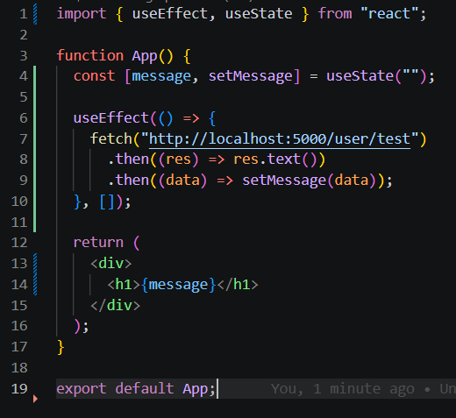

- import { useEffect, useState } from "react";
- useEffect means Runs code automatically when page loads.
- useState means Stores data inside UI.
- I designed UI sepratly so then I can maintain UI easily and connect it to main file (app.js)

Backend Setup (Server)
- In backend specially I created model folder and inside it I create task.js file. Its mainly focused what is structure of data I enter
- And also I create route folder inside it I created taskroutes.js file inside it. Its mainly focused on about routes. When I send request to backend (server.js) its find routes in taskroutes.js file then after connect mongodb, update database and give response back to the clint
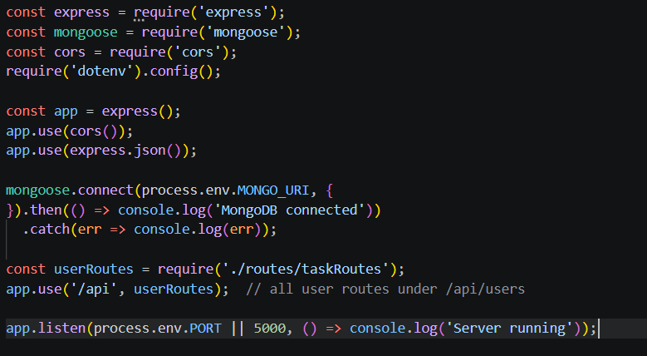
Figure 01: Server.js file

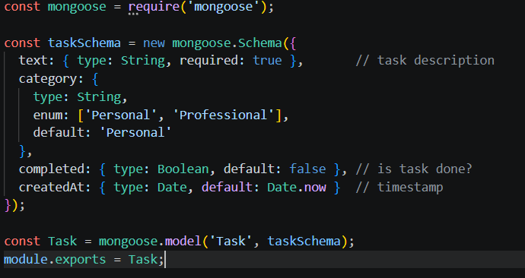
Figure 02: Task.js
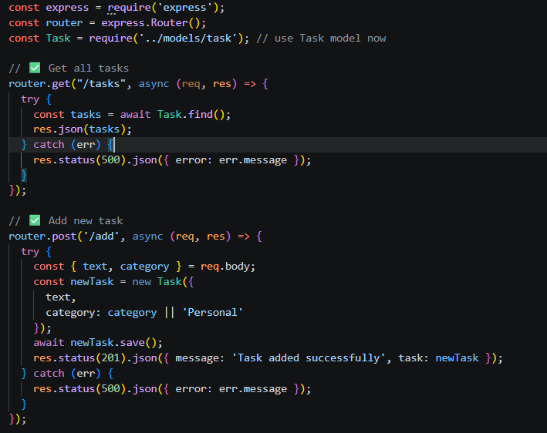
Figure 03: Routestask.js file (half a code)
Docker Containerzation
- 1st of all I created dockerfile inside client folder
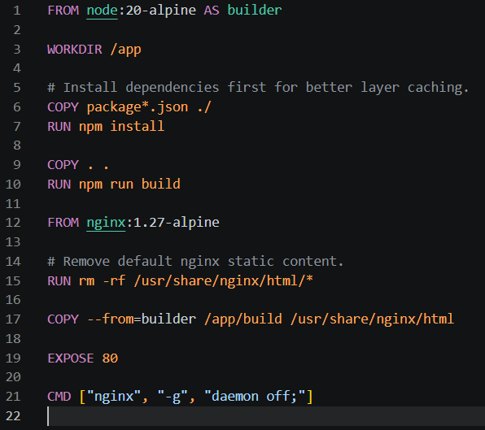

- Line number 01, AS builder means this stage name is builder
- Line number 03, Sets working folder inside container
- Line number 10, This creates React production build
- Line number 12, Instead of Node.js, now it uses Nginx web server. This keeps image smaller
- Line number 15, Deletes default Nginx welcome page files. Normally Nginx shows: Welcome to nginx. (This removes that.)
- Line number 17, This copies built React files from first stage. From /Client/build
To: /usr/share/nginx/html (This is Nginx’s website folder) So Nginx now serves your React app
- Tells Docker: This container uses port 80. That is HTTP default port.
- Starts Nginx - daemon off means: keep nginx running in foreground because of Docker needs one main process running. So, container stays alive
(Simple with daemon off terminal is showing nginx running, by default nginx running in background and terminal is free. Its not suit for this because container want to see at least one running process, so with daemon off fix this, this ensure nginx running on foreground and do not go to background)

- After client docker file I created docker file for server
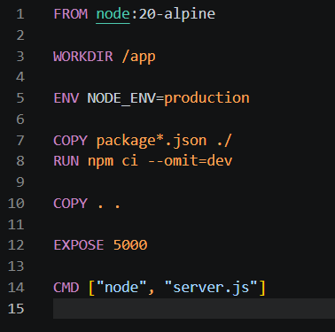
- Line number 5 Sets NODE_ENV to production. This tells Node & packages like Express that you are in production mode
- npm ci = clean install based on package-lock.json
- --omit=dev = skips devDependencies (only installs production packages). This keeps the image smaller and lean for production.
- Line number 12, Tells Docker that your app will use port 5000. This does not publish the port to host automatically; just informs Docker.

- After I create a docker-compose.yml file
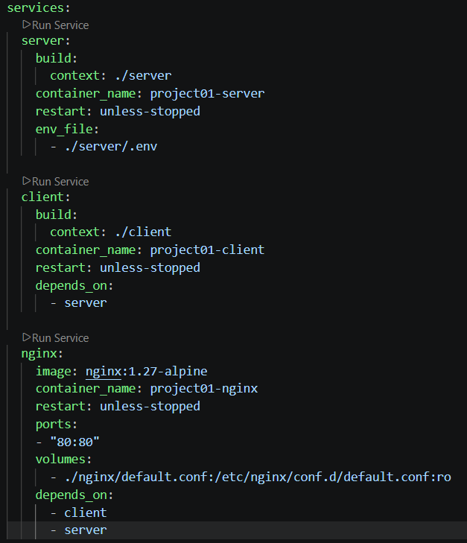
- restart: unless-stopped means Docker will automatically restart the container if it crashes, But won’t restart if you manually stop it.
- in nginx server volumes section means, Mounts your local Nginx config file (./nginx/default.conf) into the container
- :ro = read-only (Nginx can read it but not change it)
- This allows you to customize Nginx behavior (like proxy to your backend/frontend)
- After I hide this ports using env file, I created env file on root folder and type NGINX_HOST_PORT=80
NGINX_CONTAINER_PORT=80
- Then I change docker compose
ports:
- "${NGINX_HOST_PORT}:${NGINX_CONTAINER_PORT}"

NGINX Configuration

- Finnaly I created default.config file in the ngix folder
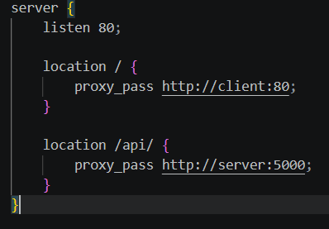
- This starts one server block. Think of it like one website rule set
- Nginx listens on port 80
Frontend part
- if request starts with / (example: /app | /task) send it to: http://client:80
Backend part
- if request starts with /api/ (example : /api/tasks | /api/users) send it to: http://server:5000

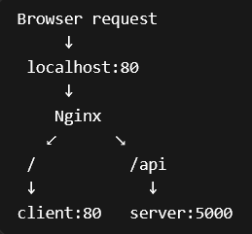
- FLOW DIAGRAME
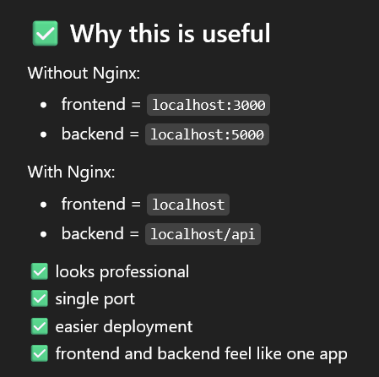
Jenkins pipelines Setup
- Checkout stage
What checkout actually does
- connects to GitHub repo
- pulls latest code
- checks out the branch
- places files inside Jenkins workspace
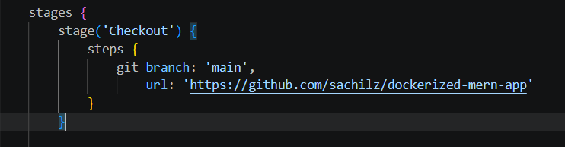
- makes code ready for next stages

- List stage
In this stage list all file and folder inside our project folder

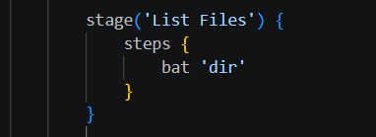

- Gitleaks Stage - 01
This is 1st security layer, in this layer do Secret Scanning (SAST Security Layer)
- Accidentally pushed .env
- JWT secrets
- MongoDB credentials
- API key
- In the top we must indicate gitleaks file path and then assign it gitleaks stage

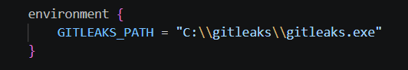
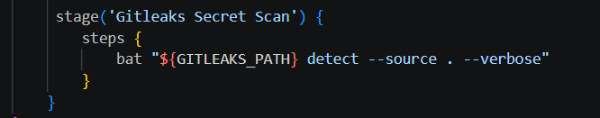

- SonarQube Stage (SAST) – 02
What is SAST means : Because it is doing code checking before running the app
SonarQube looks at it like: Let me check if this code is safe or has mistakes
SAST = Static Application Security Testing

So,
SAST | - checks code before running

DAST | - checks app while running

This check
- bugs
- security vulnerabilities
- bad coding practices
- code smell
- maintainability issues
How to setup SonarQube
- First of all, ensure u install java version 21 - Download Link
- Then u muse download sonarqube community build - Download Link
- U must download then sonarscanner also (CLI) - Download Link
- Then extract the sonarqube community setup and move it DISK C, then go to inside that folder and go bin folder and then windows-x86-64 folder inside it has StartSonar.bat file. Open it and wait 1-2 minute

- After that u can go to browser and type http://localhost:9000 and login by typing user name as admin and password as admin. Then u can change ur password If want.
- After that u must create a token (IMPORTANT) to do that go to ur account (TOP RIGHT) u can see profile icon and go to my account under it select security and then u can create token.
- Give any name for token and use expiration as NO EXPIRE and type as PROJECT ANALYSIS TOKEN then create. Copy it and later u can’t see it
- Now go to Jenkins and install plugins (SonarQube Scanner) install it
- Then go to Jenkins setting and go credentials click add credentials after u must select secret text. Scope must be global and in secret section paste that copied token from SQ
- In the id section u must add anything u want (RECOMMAND : use small word) because we wanna it later.
- Then extract CLI Package and paste it into DISK C and go to inside that folder then go to bin folder and u see SonarScanner.bat file
- Go to inside Jenkins setting and click system. Scroll to bottom find SonarQube servers
- Tick Environment variables Square
- Name as “sonarqube” – we must this one later
- Server URL as http://localhost:9000
- Server authentication token add token from credential we add it earlier
- Then after doing those things apply and save
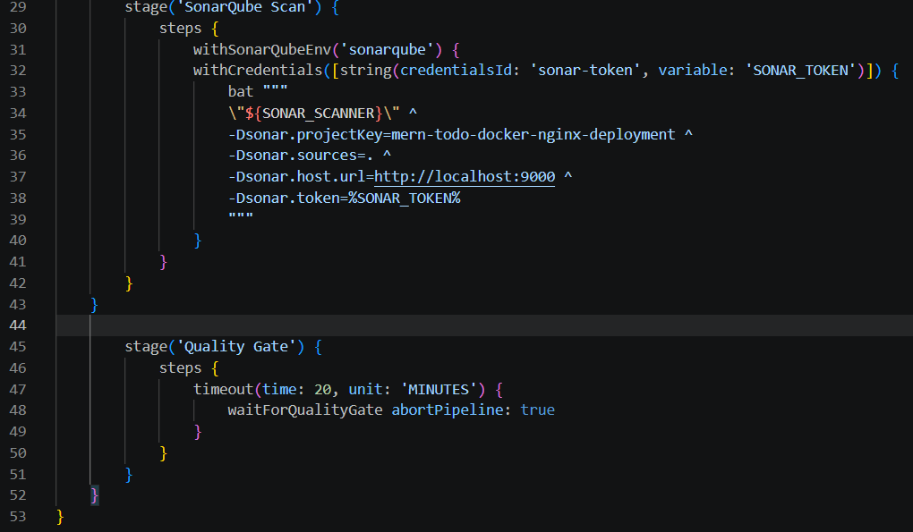

Code Explanation
- Line number 31 - connects Jenkins to your SonarQube server. Must match sonarqube as exact name when u add ID as Jenkins credentials
- Line number 32 - safely gets your Sonar token from Jenkins secrets. I will explain how I get that line (that line created by Jenkins)
withCredentials([string(credentialsId: 'sonar-token', variable: 'SONAR_TOKEN')])
- Go to ur Jenkins pipelines build page and click a config
- After go to inside it go pipeline section and bellow that u can see pipelines syntax click it
- In Sample Step click and drop down it then u must find with credential label and select it
- In Bindings add secret text and set variable as u can any name and Credentials as u must add earlier, we add token as credentials u can add it this
- Then create pipeline generate script button then u can copy that code line and put ur code
- Line number 33 - runs the scanner command on Windows (Jenkins send my project code to SonarQube for checking)
- Line number 34 - This is the path to SonarScanner. We added top of the pipline
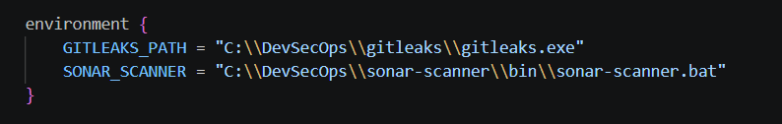
- Line number 35 - This is your project name / ID in SonarQube dashboard. (u can change it)
- Line number 36 - Sonar scans all code in current Jenkins workspace. This “.” Means Current folder
- Line number 37 - This tells SonarScanner where your SonarQube server is running.
- Line number 38 - This is the password-like secret token. It allows Jenkins to send code to SonarQube securely
- ^ means - This is only for Windows multi-line command continuation. It means continue command in next line Without ^, CMD thinks command ended. So all lines become one single scanner command.

Quality Gate Stage
- Line number 47 - wait maximum 20 minutes. Jenkins waits for SonarQube result.
Because SonarQube needs some time to analyze your code.
(I Faced issue in this section)
- I run it but not completed because Jenkins wait for sonarqube result. But Jenkins don’t get it. Because between Jenkins and SQ dosen’t have proper communication.
- So I use solution as Webhook in the sonarqube
- How I do it, Lets look at the that thing
- Go to sonarqube and then go to administration section after left panel u see Configuration, under it u see webhook
- When u add webhook u must use engrok (Because http not supported webhook)
- Sample URL – http://localhost:8080/sonarqube-webhook/
- After NGROX it look like this – https://xyz.124/sonarqube-webhook/
- This /sonarqube-webhook/ is unique
- Line number 48 – wait for the SQ report if that Pass or fail. abortPipeline: true means stop everything if quality is bad

Hadolint Scan
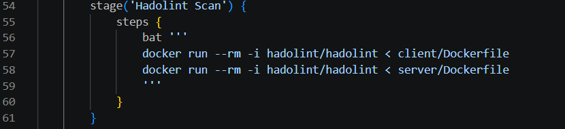
- This layer check dockerfiles
- Hadolint scans Dockerfiles for
- insecure base image usage
- latest tag usage
- root user issues
- apk/apt cache issues
- missing WORKDIR
- unnecessary sudo
- bad COPY usage
- layer optimization

- Line number 56 - your Jenkins runs on Windows, bat means: Run Windows batch commands. If Linux → use sh
- Line number 57 - This runs the official Docker image hadolint/hadolint
- docker run - Start a temporary container
- -- rm - Delete container automatically after scan. So Jenkins won’t keep unnecessary stopped containers.
- -i - Interactive input mode. Means pass Dockerfile content into Hadolint container through STDIN
- hadolint/hadolint - first hadolint → Docker Hub repository | second hadolint → image name
- < client/Dockerfile - Open client/Dockerfile then send all its text into the Hadolint container after Hadolint scans that content

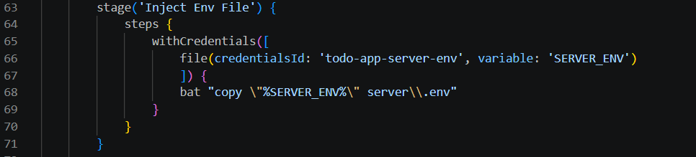
Inject Env File

- In this stage we must add env file for our Jenkins credentials if not our backend or env related files are not work
- After adding credentials, we have to create a pipelines syntax using Jenkins configuration. I created a that syntax and line number 65 – 67 is showing that syntax
- Line number 68 - copy the secret .env file from Jenkins credentials into your project’s server/.env. This is how your backend gets environment variables securely during pipeline runtime

Trivy Base Image Scan
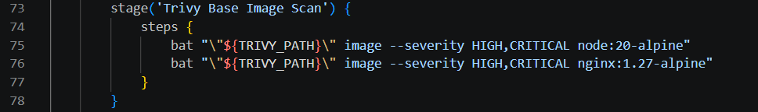
- So this stage checks whether the foundation of your containers is already vulnerable. Trivy analyzes image layers, installed OS packages, and metadata, and filters to only HIGH/CRITICAL findings
- Check whether these official parent images (node:20-alpine / nginx) already contain CVEs
- Line number 75 - This scans the official Node.js Alpine base image. It checks
- Alpine OS packages
- OpenSSL
- Busybox
- Libc
- Node runtime packages
- package manager libraries
- Line number 76 - This scans the official Nginx reverse proxy base image. It checks
- nginx binary
- Alpine packages
- OpenSSL
- SSL libraries
- OS packages

Docker Compose Build
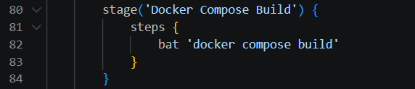
- In this stage building docker images and container using docker compose file

Trivy final image Scan
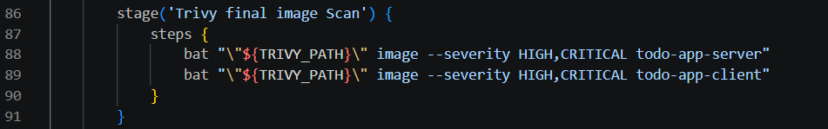
- In this stage scan each container-based image (Final scan)
- Line number 88-89 scan server image and client image
Run Containers
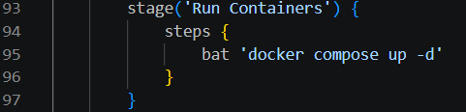
- -d means detached mode. So when run this terminal become free process running foreground

Full Jenkins Pipeline
https://github.com/sachilz/CI-CD-Enabled-MERN-Stack-Todo-Application/blob/main/Jenkinsfile

Deploy On AWS
- First of all, at the beginning we run this 1 EC2 instance
- So, all files go to 1 EC2 instance
- So, to do this create EC2 instance and use free tier (t3.micro)
- After change ports (for my one – Nginx port 80 and Backend Port 500) setup it
- To setup it clicks EC2 instance and go security section under this edit inbound ports. Add custom port as 80 and 5000 then save
- When creating instance must be create keypair and save it
- Then create a folder inside ur computer and put that .pem file into it
- Then open that folder through vscode and then open terminal
- Type this ssh -t (keypare name – demo.pem) ubuntu@(ur instance public ip)
ssh -i ubuntu@56.89.21.135
- Then u can go to insider server
- After going inside server setup, it like this (this is depended on ur project dependencies)
- Crate a folder inside server – mkdir project1
- Then update ur package – sudo apt update
- Install git – sudo apt install git -y
- Install node - sudo apt install -y nodejs {if this install old node version then u must download ur preferd version}
- To do this first check ur node version using node -v
- If its old, run these command
curl -o- https://raw.githubusercontent.com/nvm-sh/nvm/v0.39.7/install.sh | bash
source ~/.bashrc
nvm install 21
nvm use 21
- Then check again node -v
- Install npm – sudo apt install npm
- Done now u have to clone ur project – sudo git clone <repo link>
- Now go to ur folder (for me I have sever and client file) first of all I go to server folder and run npm install then go to client folder and run npm install. This create nodemodules folder inside each folder
- One more thing if u use .env file in this instance its missing because its ignore by gitignore. We have to setup it like this go to ur env file folder (for me I setup it server folder) go to server folder - cd server
- Then create .env file using touch .env
- Now edit nano .env
- Now u can write inside it all of this and after write press CTRL + X and then Press Y then ENTER

- If u want to install nodemon then run this npm install -g nodemon (OPTIONAL)
- Now install docker compose using sudo apt install docker-compose -y
- Now u can run docker compose - sudo docker-compose up -d –build
- we use –build
- Rebuild your images from Dockerfile
- Reinstall dependencies if needed
- Pick up latest code changes
- Then start containers

